

University of Debrecen
Faculty of Engineering
Department of Electrical Engineering and
Mechatronics

Second homework

Electrical Machines and Drives
2025/2026/II. semester
Title:
Design and Implementation of Motor Control Strategies: Single-Loop, Cascade, and Inverter-Based Control for DC and Induction Motors
Created by:
Name:  Neptun:  Department:  Date:  Signature: | Mohammed Mohammed Emad Said Soliman  UHCI4H  Mechatronics Engineer BSc.  11/ 4 / 2026
Contents
Second homework 1
I. Introduction: 2
II. TASK 1: SINGLE-LOOP CONTROL 2
Speed Control – Block Diagram Model 2
Speed Control – Simscape Block Model 3
Position Control – Block Diagram Model 4
Position Control – Simscape Block Model 4
Results and Comparison 5
III. TASK 2: CASCADE CONTROL 6
IV. TASK 3: INVERTER-BASED INDUCTION MOTOR DRIVE 8
Three-Phase Inverter Design 8
PWM Signal Generation 9
Simulation and Results 9
V. Conclusion 11

- Introduction:
This report describes the design, implementation and analysis of motor control q qstrategies for the second homework assignment. This work includes three tasks: a single loop control of DC motors, cascade control with an inner current loop and an outer speed loop, and closed loop speed control of a three phase induction motor using an inverter.
Task 1: Design and implementation of separate single-loop controllers for speed and position of a DC permanent magnet motor using block diagram model and Simscape model. Design and comparison of PID and PI controllers.
Cascade control is introduced in task 2, with the outer loop controlling speed, and the inner loop controlling armature current. The two loops are equipped with PI controllers with anti-windup features.
The extension of Task 3 to be used for AC drives is to design a three-phase voltage source inverter (VSI) using MOSFET switches to drive a squirrel-cage induction motor. The generation of PWM and V/f control are realized and studied.
All simulations are done using MATLAB/Simulink and SimScape Electrical (Specialized Power Systems).

- TASK 1: SINGLE-LOOP CONTROL

Speed Control – Block Diagram Model
Two variants are implemented: a gain-based PI controller and a Simulink PID block. The closed-loop transfer function with PI control is third-order. Parameters are tuned for fast rise time with minimal overshoot.
PID block implementation uses the Simulink PID Tuner with specified bandwidth and phase margin.
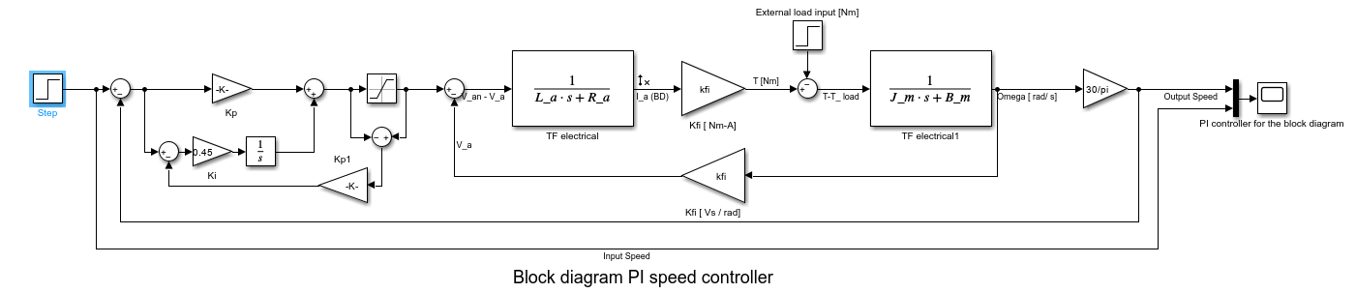
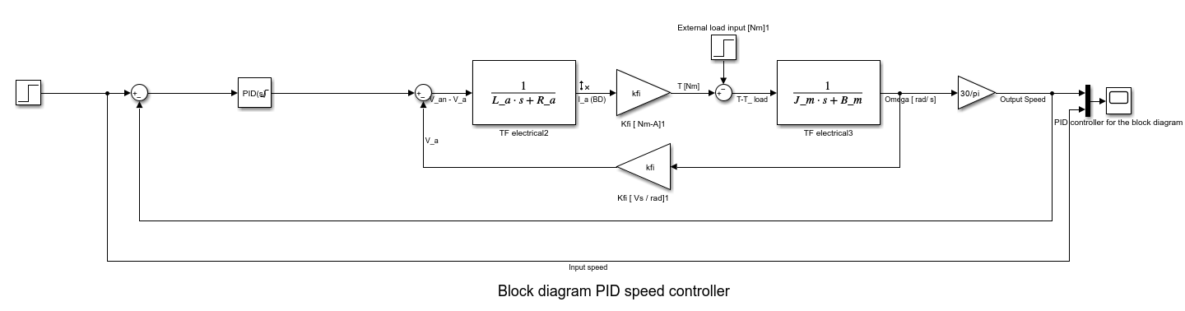

Speed Control – Simscape Block Model
The Simscape model uses the DC Permanent Magnet Motor block with a PID Controller generating the armature voltage command through a controlled voltage source.
Structure:
- Step reference (rpm → rad/s)
- PID Controller with anti-windup
- DC motor with load torque input
- Speed feedback (rad/s → rpm)
- Scope for speed and current monitoring
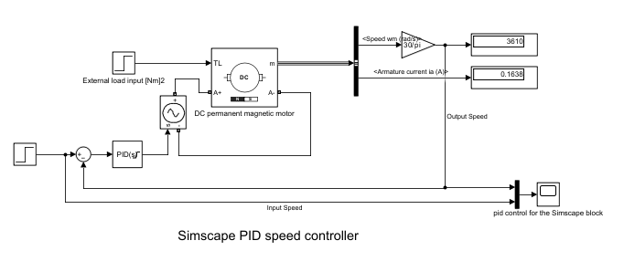
The Simscape model captures nonlinear electromechanical coupling without linearization.

Position Control – Block Diagram Model
A PID controller is implemented for angular position control. The plant has an additional integrator (position = ∫ speed), making the system type 2.
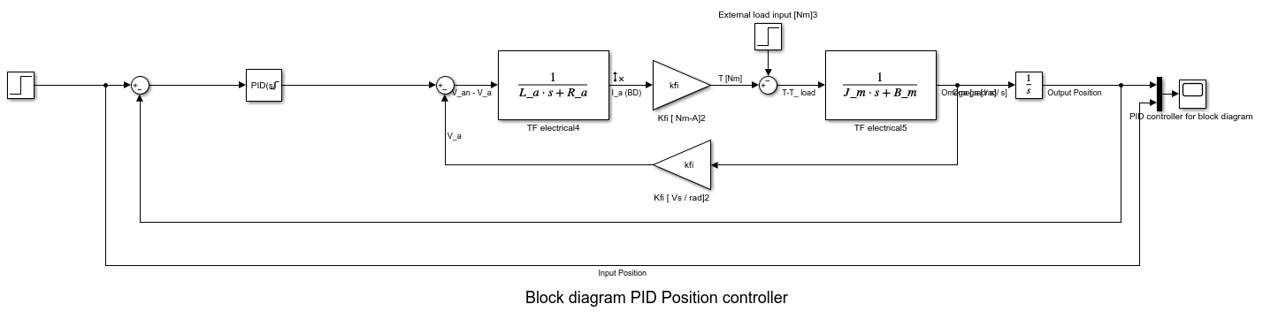
Parameters are tuned using Ziegler-Nichols followed by simulation refinement for <5% overshoot and settling time <0.1 s.

Position Control – Simscape Block Model
The Simscape position controller adds an outer position loop to the speed controller. Motor speed is integrated to obtain position, which is compared with the reference. The PID output serves as the speed reference.
A step position reference of 1.6 rad is used for testing. Anti-windup prevents saturation during transients.
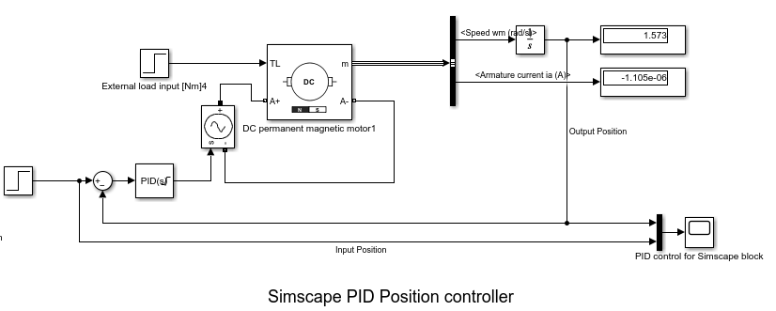

Results and Comparison
All four controllers are tested with identical references and load conditions.
- Speed control results:
- Both PI and PID controllers track 3600 rpm reference successfully
- PI controller: smooth acceleration, minimal overshoot
- PID controller: slightly faster response due to derivative damping
- Zero steady-state error due to integral action
Position control results:
- Block diagram PID: target position reached with negligible error
- Simscape PID: similar performance with physical constraints included
Key findings:
- Block diagram models provide idealized behavior for theoretical analysis
- Simscape models offer realistic predictions with nonlinear effects
- PID outperforms PI for position control due to added damping
- All controllers exhibit zero steady-state error for constant references
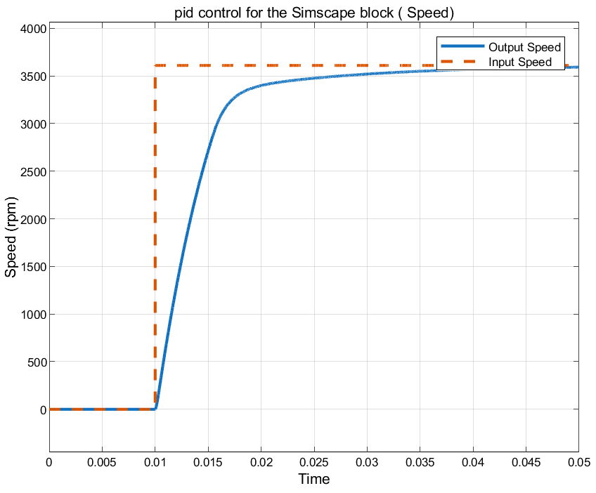
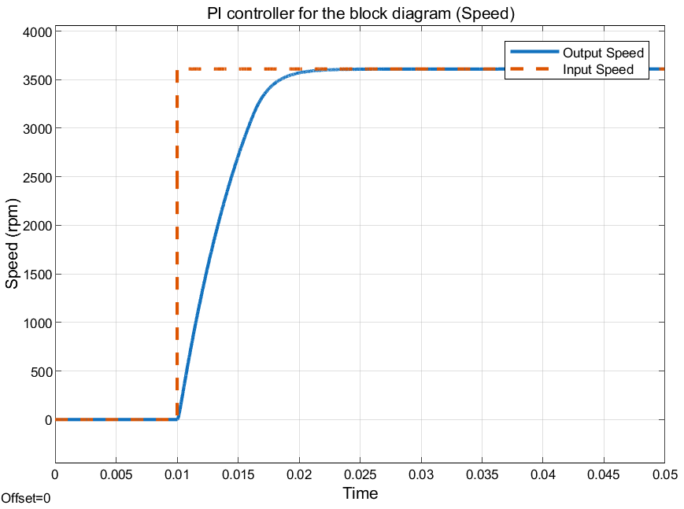

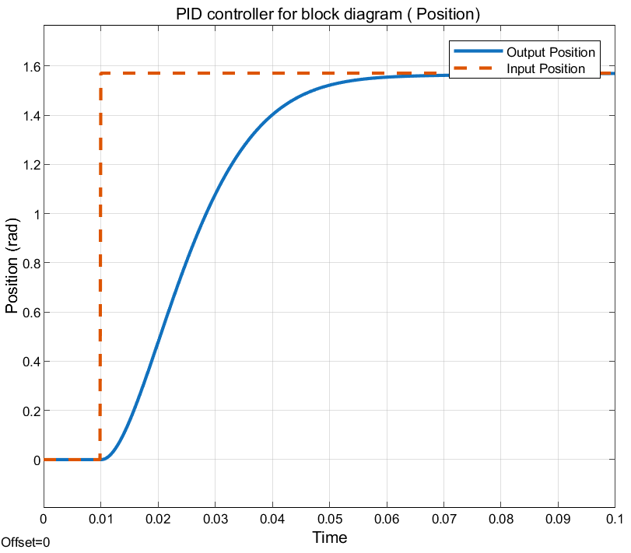
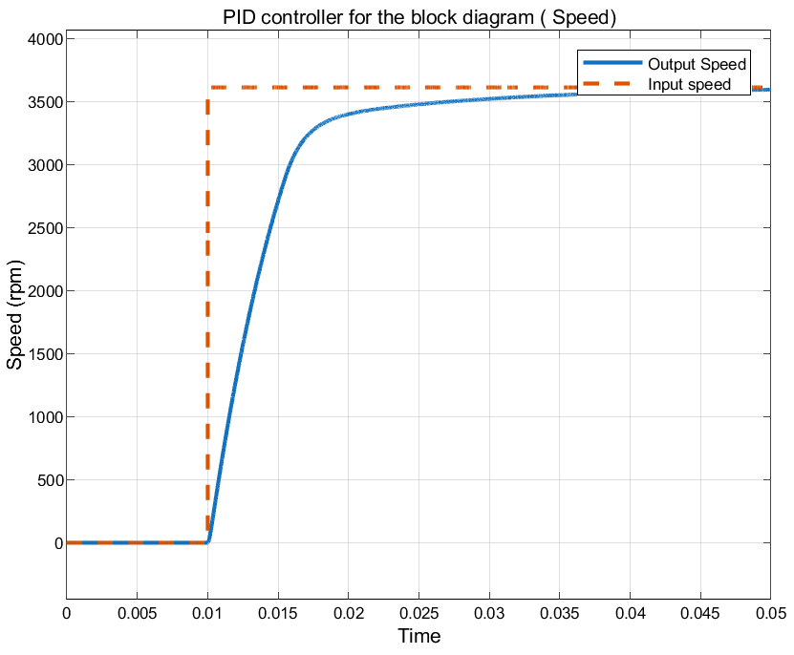
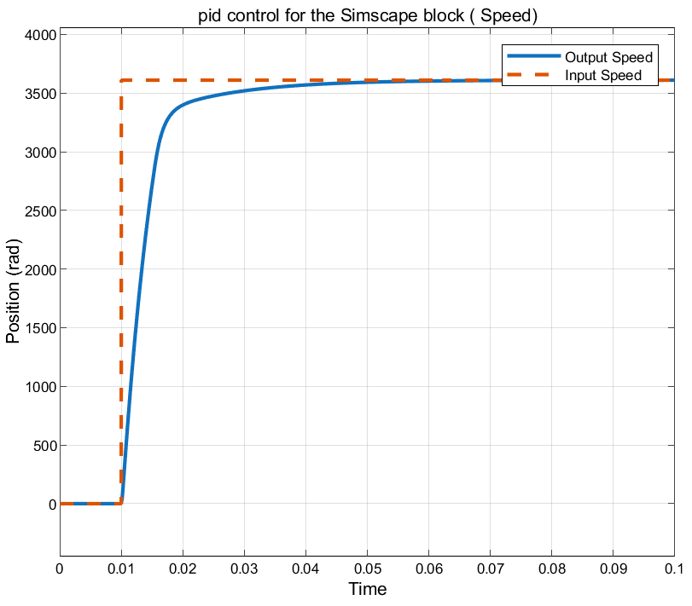

- TASK 2: CASCADE CONTROL
Cascade control is a double loop control, with an inner fast loop for armature current and an outer slow loop for motor speed. This separation enhances disturbance rejection as current disturbances are corrected before affecting speed.
The inner loop regulates the armature current by varying the voltage applied to the armature. This outer loop is used to control the speed by providing the reference for the inner loop. Both loops are realized with PI controllers using gain blocks.
The current loop includes back-EMF compensation. The measured motor speed is fed back to cancel back-EMF voltage to enhance current tracking during speed transients.
Anti-windup protection is used to avoid integrator saturation when the controller output is at limits. If the output is saturated, the difference between the limited and unlimited output is fed back to the integrator via a tracking gain. This prevents the integrator from building up too much error.
The inner current loop is intended to be 5-10 times faster than the outer speed loop. This will prevent the current dynamics from being disturbed before the speed controller makes its next adjustment.
The inner current loop follows its reference in 1-2 milliseconds as simulated. The outer speed loop is smooth with little overshoot to the reference. The cascade controller recovers faster and with less speed deviation when a load torque disturbance is applied, compared to the single-loop controller of Task 1.
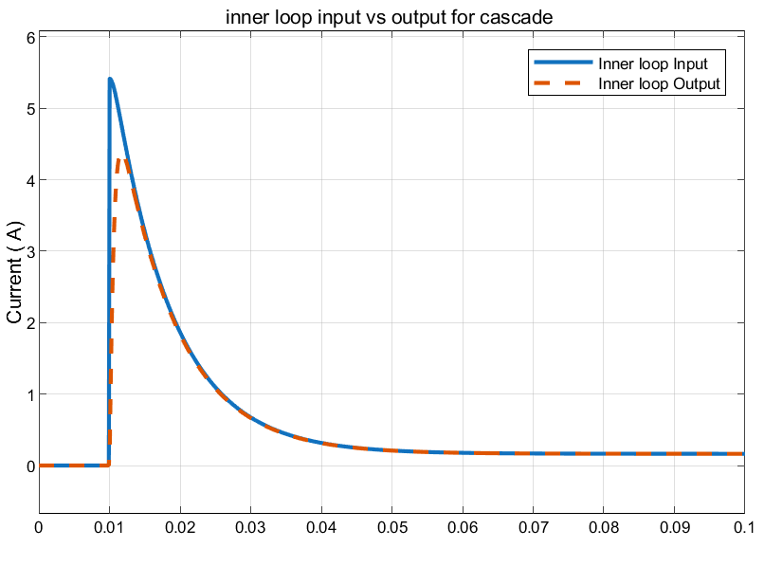
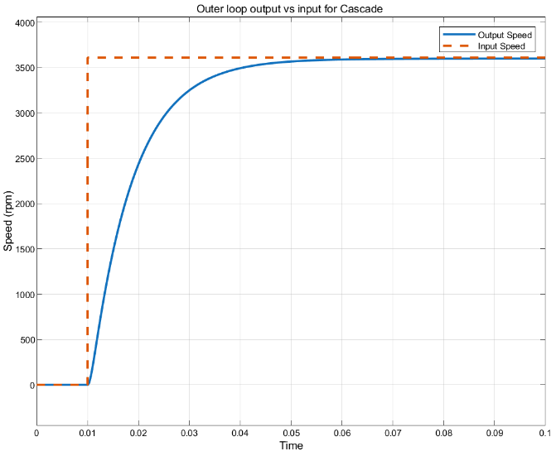
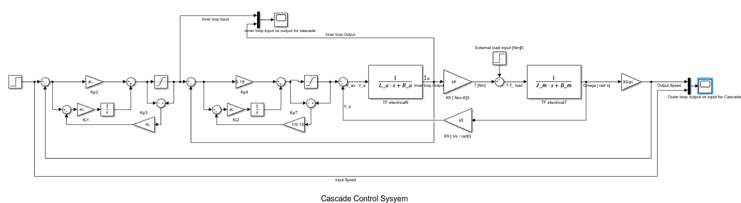
The anti-windup feature ensures that the integrator output remains within reasonable bounds when the reference step changes, thus avoiding large overshoot.

- TASK 3: INVERTER-BASED INDUCTION MOTOR DRIVE
The task is to design a three-phase voltage source inverter to supply a squirrel-cage induction motor using Simscape Electrical. The inverter converts DC voltage to variable-frequency three-phase AC through PWM switching.

Three-Phase Inverter Design
The inverter uses six MOSFET switches in a three-phase bridge configuration. The DC source is 300 V. The top row consists of switches AH(S1), BH(S3), and CH(S5) with drains connected to the positive DC bus and sources to phase outputs A, B, and C. The bottom row consists of switches AL(S2), BL(S4), and CL(S6) with drains connected to phase outputs and sources to the negative DC bus.
Phase outputs A, B, and C connect to the motor stator terminals a1, b1, and c1. The motor neutral terminals a2, b2, and c2 are tied together. A ground reference connects to the negative DC rail. The powergui block is set to Continuous simulation mode.
A three-phase currents measurement block is placed in the phase lines. A three-phase voltages measurement block is connected to the motor terminals. The motor thermal port C is terminated with f(x)=0. The mechanical port R connects to scopes for speed and angular position monitoring.
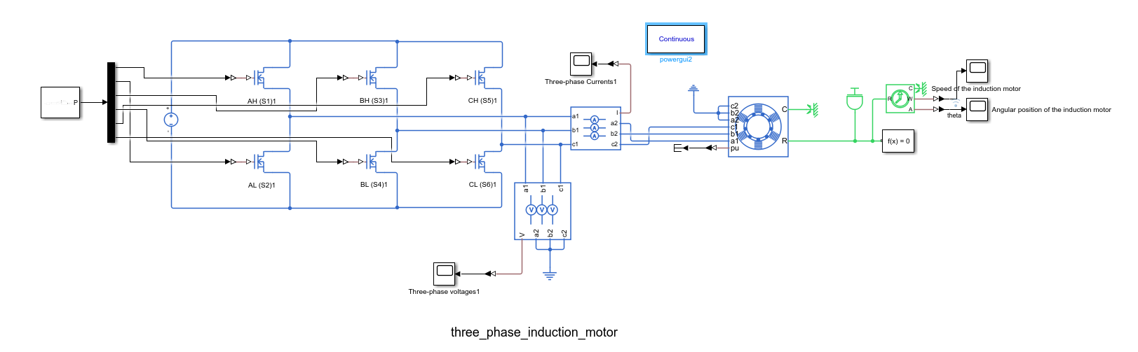

PWM Signal Generation
The PWM Generator (2-Level) block produces six gate signals for the MOSFET switches. The settings are:
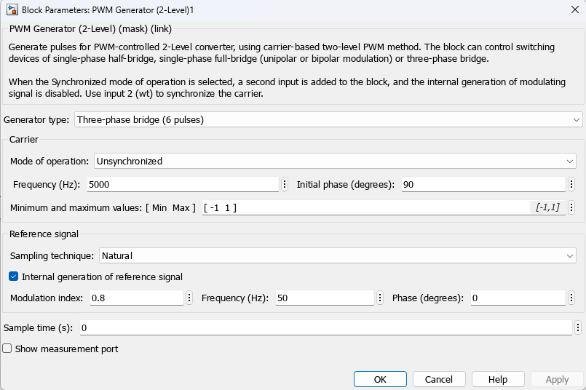
The six output pulses are demultiplexed and connected to the individual MOSFET gates. The internal reference generation produces the three-phase sinusoidal modulating signals internally.

Simulation and Results
The simulation runs for 0.5 seconds. The motor operates under no-load conditions. The key observations from the simulation outputs are:
Three-phase voltages: The inverter output shows PWM stepped waveforms with switching transitions at the 5 kHz carrier frequency. The fundamental component is at 50 Hz.
Three-phase currents: The motor currents are nearly sinusoidal due to the inductive filtering of the stator windings. The three phases are balanced with 120-degree displacement.
Motor speed: The speed increases continuously from standstill under no-load conditions, showing the acceleration characteristic of the induction motor when supplied with constant voltage and frequency.
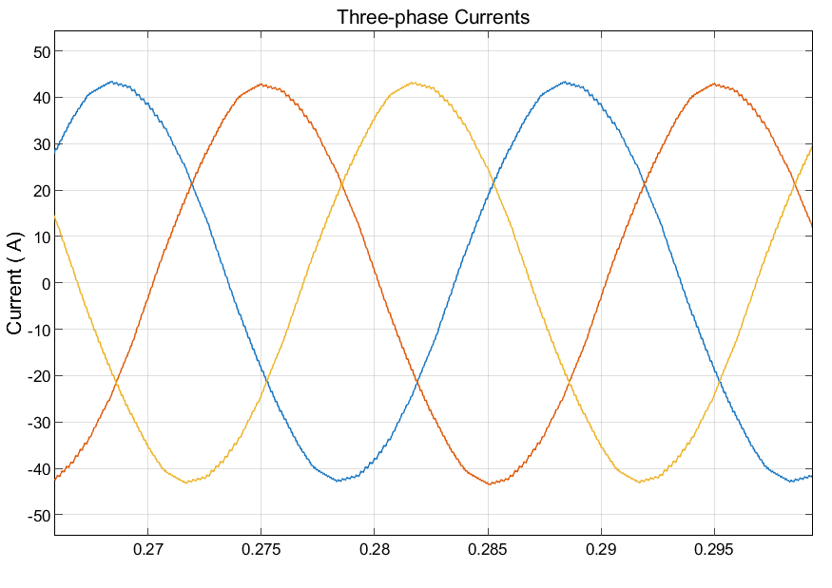
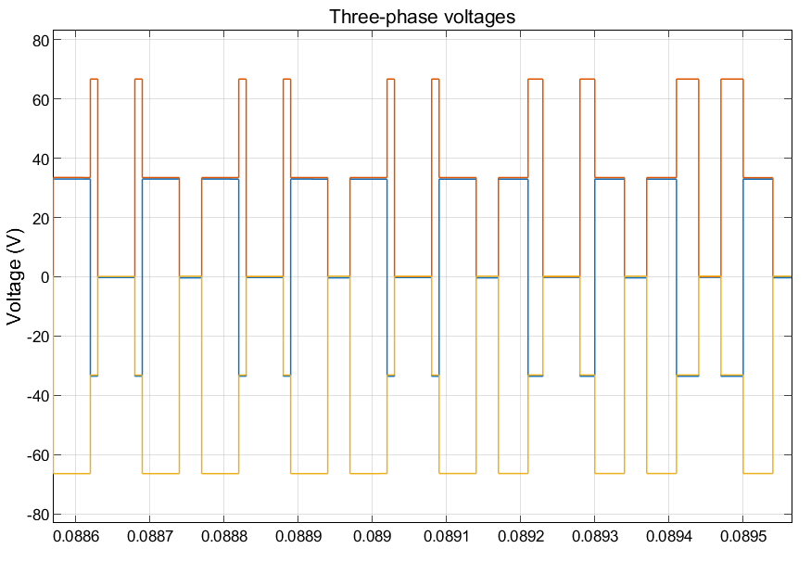
Angular position: The rotor position increases as the integral of speed, showing the cumulative rotation of the motor shaft.
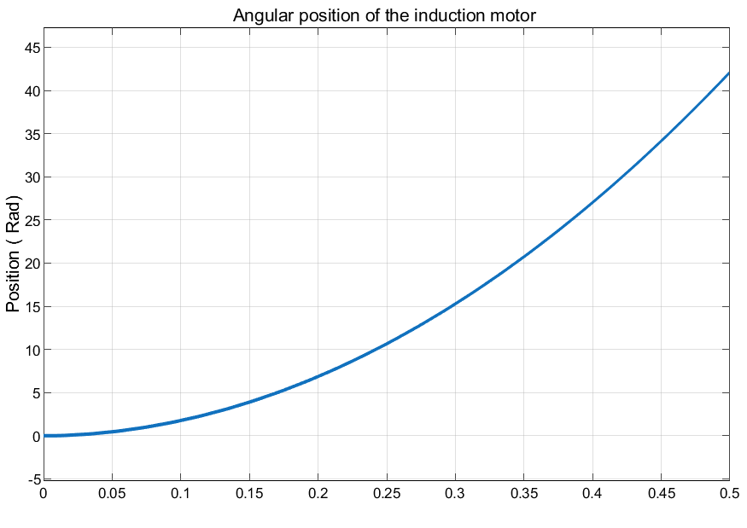
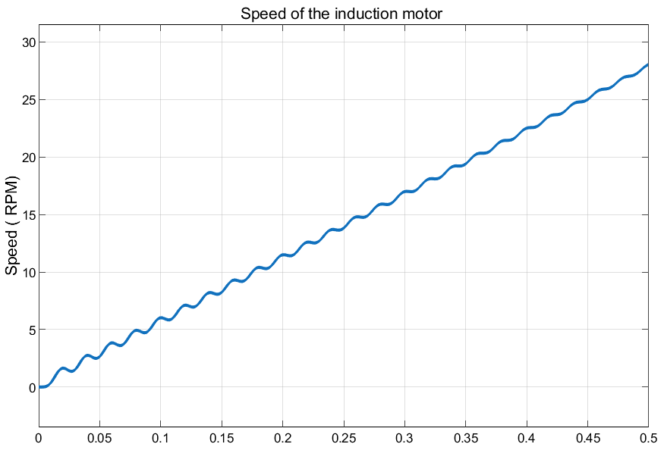

- Conclusion
This report presented three motor control strategies for the second homework assignment.
Task 1 implemented single-loop PI and PID controllers for DC motor speed and position control using both block diagram and Simscape models. PID provided better damping for position control, while both approaches achieved zero steady-state error. Simscape models captured nonlinear effects absent in linear block diagrams.
Task 2 designed a cascade control system with an inner current loop and outer speed loop using gain-based PI controllers. Anti-windup protection prevented saturation. The cascade structure demonstrated superior disturbance rejection compared to single-loop control, with faster recovery under load torque disturbances.
Task 3 built a three-phase voltage source inverter using six MOSFET switches to supply an induction motor. PWM generation at 5 kHz carrier frequency with 0.8 modulation index produced the gate signals. The simulation showed PWM voltage waveforms, sinusoidal motor currents, and continuous speed acceleration under no-load conditions.

